

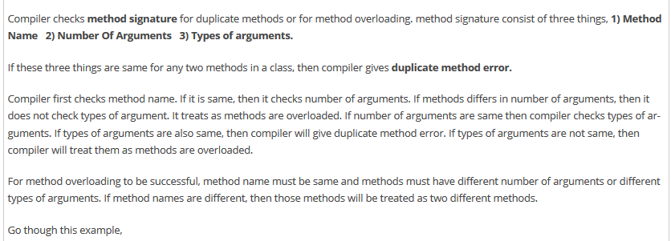



Example of method overloading in selenium



Note: Return type does not matter in method overloading. It can be same and can be different. For instance, if there are two methods with same name but different return types then these methods are not overloaded. Compiler checks only method signature while checking method overriding.

We also following other type of overloading as well

1. Operator overloading:



1. Constructor overloading:



Important note: Casting of objects with different classes is other form of polymorphism.



